Accidental Drug Related Deaths

Group 4: Tutorial

What you will need:

* A web browser and internet connection
* A Microsoft Azure ML account
* The Accidental_Drug_Related_Deaths_2012-2018.csv

**Step 1:** “**Click**” on the following link <https://catalog.data.gov/dataset/accidental-drug-related-deaths-january-2012-sept-2015>

**Step 2:** **“Click”** on the **Comma Separate Values Files** download button to download the csv. file

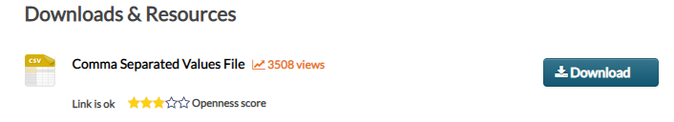

**Note:** If your web browser saves the file in a default folder make not of the location or save the file where you can access for a later step

**Step 3:** “**Click**” on the following link and log into your Microsoft Azure ML account:

<https://studio.azureml.net>

**Step 4:** **“Click”** on the **my experiments** button



**Step 5:** **“Click”** on **DATASET** and then **“click”** on **FROM LOCAL FILE**

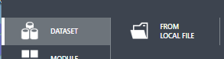

**Step 6:** **“Click”** on **Choose File**

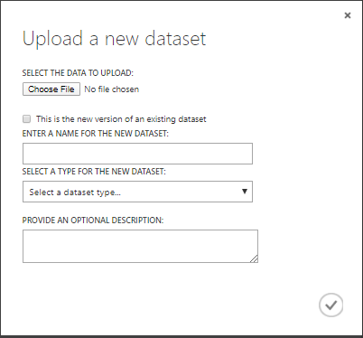

**Step 7:** Locate the Accidental_Drug_Related_Deaths_2012-2018.csv file you downloaded in Step 2 and **“click”** open

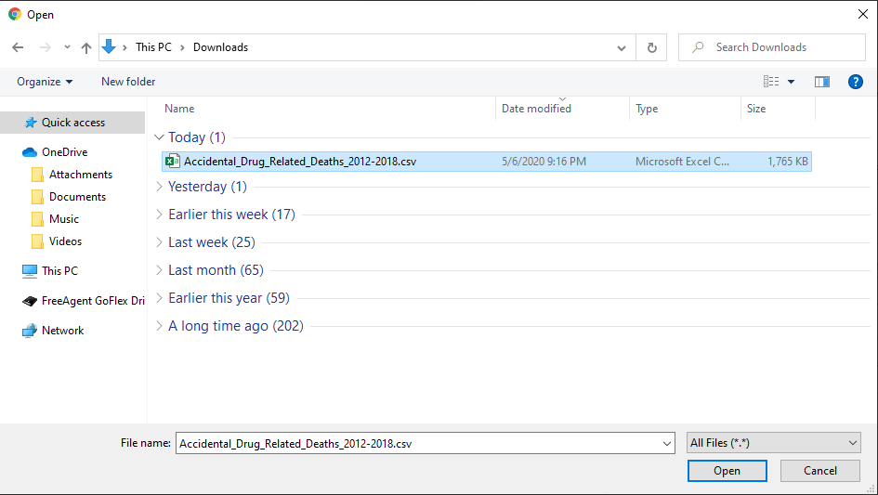

**Step 8: “Click”** on the check mark/ok button

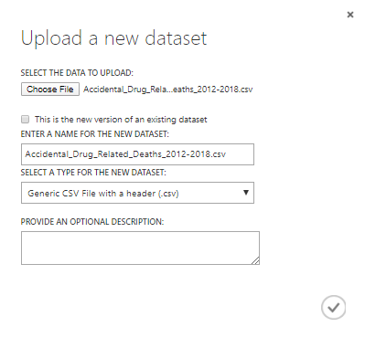

**Step 9: “Click”** on the **+ NEW** button in the lower left hand corner



**Step 10: “Click”** on **Blank Experiment**

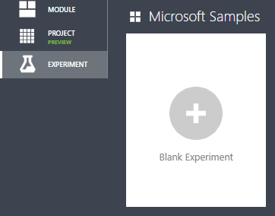

**Step 11:** At the top of your UI label your experiment **Accidental Drug Related Deaths**

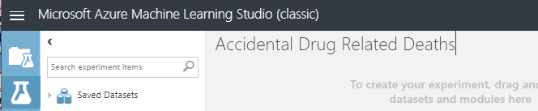

**Step 12: “Click”** on **Saved Datasets**, then click on **My Datasets**, and dragged the **Accidental_Drug_Related_Deaths_2012-2018.csv dataset** upload onto the canvas

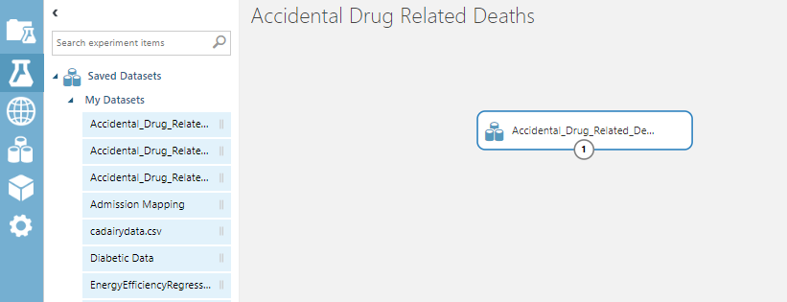

**Step 13: “Search”** in the Search experiment items field for **Select Columns in Dataset** module and drag the module onto the canvas underneath the **Accidental_Drug_Related_Deaths_2012-2018.csv dataset** module

**Step 14: “Connect”** the outbound of the **Accidental_Drug_Related_Deaths_2012-2018.csv dataset** module to the inbound of the **Select Columns in Dataset** module

**Step 15: “Click”** on the **Select Columns in Dataset** module and look to the right Properties panel and **“Click”** on **Launch column selector** button

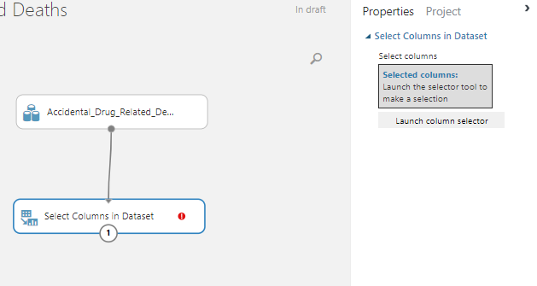

**Step 16: “Add”** the following columns **Age, Sex, Race, ResidenceCity, DeathCity,** and **Location** then **“click”** onthe **check/ok** button

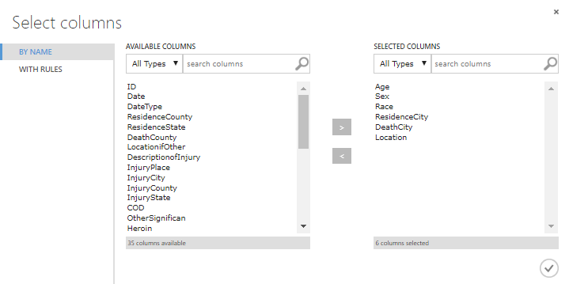

**Step 17: “Click”** the **SAVE** button and **RUN.** When it is done running **“click”** on the outbound of the **Select Columns in Dataset** module and select visualize. Confirm your results look like below and then **“close”** the window.

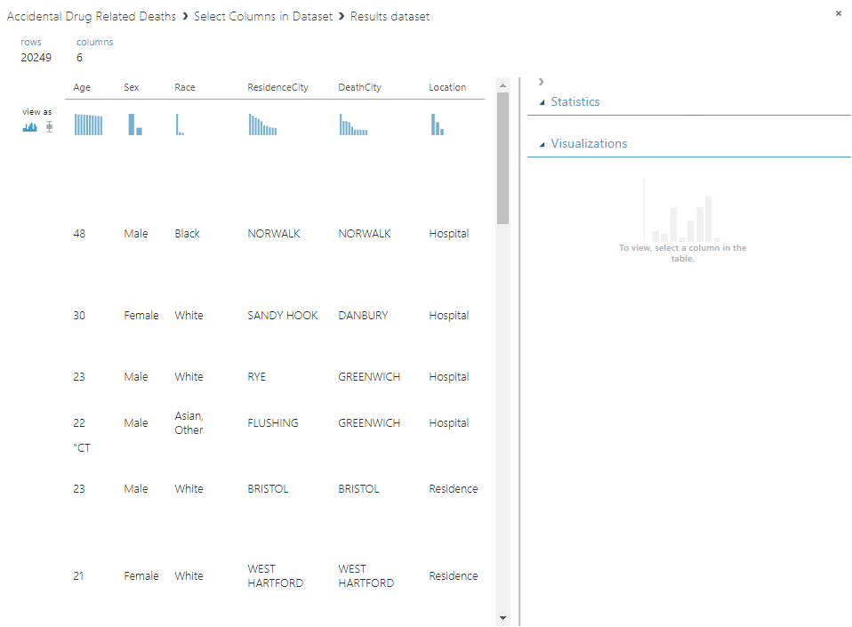

**Step 18: “Search”** in the Search experiment items field for the **Split Data** module and drag the module onto the canvas underneath the **Select Columns in Dataset** module. **“Connect”** the outbound of the **Select Columns in Dataset** module to the inbound of the **Split Data** module

**Step 19: “Select”** the **Split Data** module and look to the right Properties panel and make the following selections:

* **Splitting mode:** Split Rows
* **Fraction of rows in the first output database:** 0.7
* **Randomized split:** checked
* **Random seed:** 0
* **Stratified split:** False

**Step 20: “Search”** in the Search experiment items field for the **Train Model** module and drag the module onto the canvas underneath the **Split Data** module. **“Connect”** the 1st outbound of the **Split Data** module to the 2nd inbound of the **Train Model** module

**Step 21: “Click”** on the **Train Model** module and look to the right Properties panel and **“Click”** on **Launch column selector** button, add the **Age** column, and **“click”** onthe **check/ok** button

**Step 22: “Search”** in the Search experiment items field for the **Linear Regression** module and drag the module onto the canvas to the left of the **Split Data** module and above the **Train Model** module. **“Connect”** the outbound of the **Linear Regression** module to the 1st inbound of the **Train Model** module.

**Step 23: “Select”** the **Linear Regression** module and look to the right Properties panel and make the following selections:

* **Solution method:** Ordinary Least Squares
* **L2 regularization weight:** 0.001
* **Include intercept term:** checked
* **Random number seed:** “Leave blank”
* **Allow unknown categorical levels:** checked

**Note**: Your experiment should look like below:

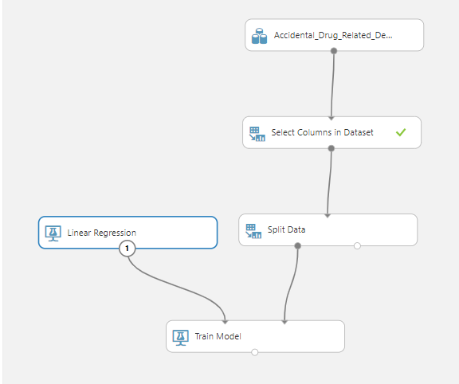

**Step 24: “Search”** in the Search experiment items field for the **Score Model** module and drag the module onto the canvas under the **Train Model** module offset to the right. “**Connect”** the 2nd outbound of the **Split Date** module to the 2nd inbound of the **Score Model** module. “**Connect”** the outbound of the **Train Model** module to the 1st inbound of the **Score Model** module.

**Step 25: “Select”** the **Score Model** module and look to the right Properties panel and make sure the **Append score columns to output** is checked

**Step 26: “Search”** in the Search experiment items field for the **Evaluate Model** module and drag the module onto the canvas under the **Score Model** module. “**Connect”** the outbound of the **Score Model** module to the 1st inbound of the **Evaluate Model** module.

**Step 27: “Click”** the **SAVE** button and **RUN.**

**Note**: Your experiment should look like below:

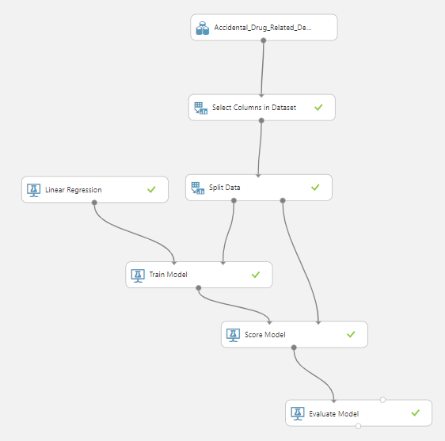

**Step 28:** When it is done running **“click”** on the outbound of the **Evaluate Model** module and select visualize. Confirm your results look like below and then **“close”** the window.

